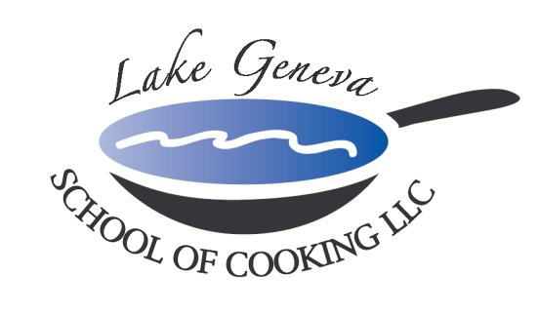

Chicken au Poivre
Cremini Mushroom Reduction

Serves 10
Ingredients:

10 chicken breasts, 5 oz. each
1 Tbsp. green peppercorns
4 Tbsps. butter
¼ cup shallots, chopped fine
1 tsp. garlic, minced
3 cups mushroom, sliced ¼” thick
2 Tbsps. Dijon mustard
3 oz. Cream Sherry
8 oz. chicken stock reduction
3 oz. heavy cream
1 Tbsp. parsley, chopped
Chef John’s Signature Seasoning, to taste

Preparation:
- Crush green peppercorns with rolling pin, or spice grinder.
- Season chicken with Chef John’s Signature Seasoning and crushed peppercorns. Coating as much of the filet with the peppercorns to your taste.
- In a large 12 inch sauté pan, heat 2 Tbsps. butter and sauté shallots and garlic for 2 minutes, add mushrooms over medium heat.
- After 4 minutes, deglaze the pan with Cream Sherry, let the flame catch the Sherry vapors and ignite it. Swirl the pan slightly and let the flame burn out.
- Add the Dijon mustard, chicken stock reduction, and let reduce in half.
- Add heavy cream, chopped parsley and Chef John’s Signature Seasoning to taste. Reduce until desired thickness.
- Set oven to 335 degrees.
- Grill chicken over medium to high heat on grill, 3 minutes on one side, pick up and rotate, grill 3 minutes and the same side, to create diamond char marks.
- Turn over the chicken and grill 3 more minutes on back side.
- Take the chicken off the grill and finish in oven for 8-10 minutes.
- Let chicken rest for 10 minutes and slice on diagonal.
- Serve with Cremini mushroom reduction.

