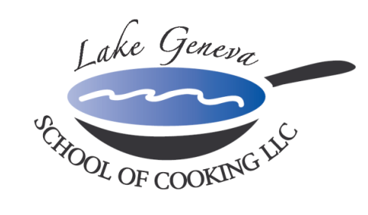

Private Parties are Our Specialty!

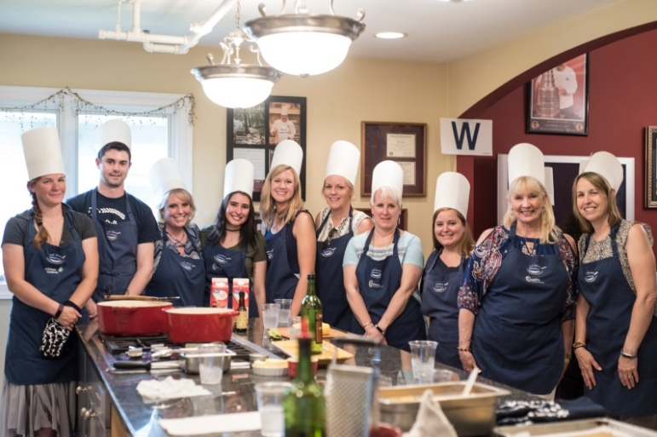
Upon arrival to the Lake Geneva School of Cooking, our staff will greet your group and provide you with a toast of sparkling wine and Parmigiano Popovers. The Chef will introduce the menu and provide a brief lesson in the basic techniques used in the preparation of each course, as well as in safety and sanitation.

The Chef will then divide the menu up into teams; each team will be responsible for creating their own segment of the meal with recipes from CHEF JOHN BOGAN RECIPES FROM THE SEASONS OF MY LIFE cook book. The Chef and his staff will float between participants to assist, offer tips and suggestions, and address questions or concerns to make sure that every dish is a success!
Once the meal preparation is completed, our guests will have the opportunity to sit down and enjoy the fine dining portion of the event.

Essentially, you will "break bread" together and enjoy a gourmet meal that was created by the entire group in the Lake Geneva School of Cooking’s Wood-Mode custom kitchen, which features Wolf and Sub-Zero appliances.

Private Facility Fee includes:
The $400 private facility fee includes a Consultation with Chef John on business meeting agenda, choice of menu options, hands-on cooking class, coaching by Chef and Staff, Sparkling Wine and Popover Reception, non-alcoholic beverages, a tasting wine while cooking and a delicious four-course meal.

Pricing:
Primary Package is $90 per participant. The Primary Package includes a hands-on class coached by Chef John and our staff, a sparkling wine and Parmigiano Popovers reception, a tasting wine and a delicious four-course meal.

Deluxe Package is $125 per participant. The Deluxe Package includes all items in the Primary Package, plus a gift bag with a Lake Geneva School of Cooking apron, Chef John’s Signature Seasoning, and kitchenware.
Cook Book Package is $150 per participant. The Cook Book Package includes all items in the Primary Package, plus a signed copy of CHEF JOHN BOGAN RECIPES FROM THE SEASONS OF MY LIFE cook book and Chef John’s Signature Seasoning.
Premier Package is $250 per participant. The Premium Package includes all items in the Deluxe Package, plus a signed copy of CHEF JOHN BOGAN RECIPES FROM THE SEASONS OF MY LIFE cook book, and a Lake Geneva School of Cooking Chef Jacket.

How to Register
For more information on customizing and setting up your Private Party, please contact Chef and owner, John Bogan, at 262-248-3933. Minimum of eight guests (Saturday requires 15) to reserve your event.
Payment Policy
Additional costs include: supplemental wine, a sales tax of 5.5% and a service charge of 20%. The Lake Geneva School of Cooking requires a 50% deposit, upon reserving the date for your event. Accepting all major credit cards, the balance must be paid in full on the date of your party.
*LGSC prohibits outside alcoholic beverages.

